Log in to a Chromebook using your Google information (Gr 3-5)

You can log in by using your Google Account username and password:

1. Enter your Google Account username (email address) into the Username field.
2. Enter your Google Account password into the Password field.
3. Click Login.
4. The option to select a profile picture appears. (may only occur if they never logged in before)
   1. Select your profile picture. Pick one of the default pictures, use your existing Google profile picture, or take a new picture.
5. Click OK.

This completes the initial login process.

Other Notes:

* At a minimum, completely shut down the device weekly. This will enable updates to occur which will keep the device running with optimum speed and the current versions of Chrome.
* Charge the device prior to using it the first time and then every evening after that. If you do not do this, you will need to be charging it while taking your lessons.
* ***NEVER***share your username and password with anyone except your parents or learning coaches.

What is Clever?

Clever is an easy way for you to access all your learning applications. With Clever, you only have to remember one username and password, or use a Clever Badge, to log into all your applications.

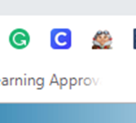When using badges, the Clever homepage will automatically open for your student. If it does not, open the Chrome browser and click on the Chrome extension for Clever (white C on a blue background).

The first time accessing Clever, it may ask you to choose your school (start typing the name of the elementary building and choose it from the list). Then just follow the instructions on the screen to enter your Google email address and your Google password.

Clever portal for students:

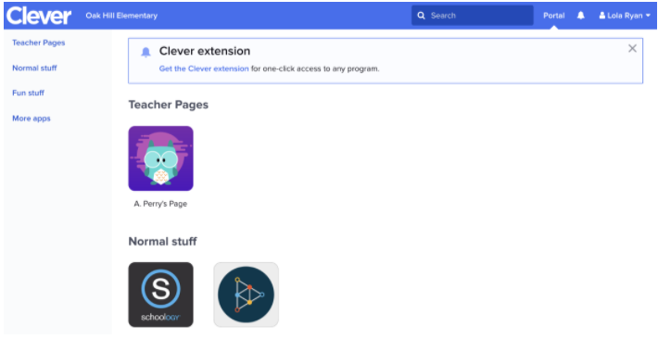

Your Clever Portal might look different, depending on the applications your school has added to Clever. If you are missing an application you need in your Clever Portal, contact your teacher!

The first time into some applications, you may need to enter your username and password but after that it will be saved in Clever (for almost all applications).